**Jenkins Credentials**

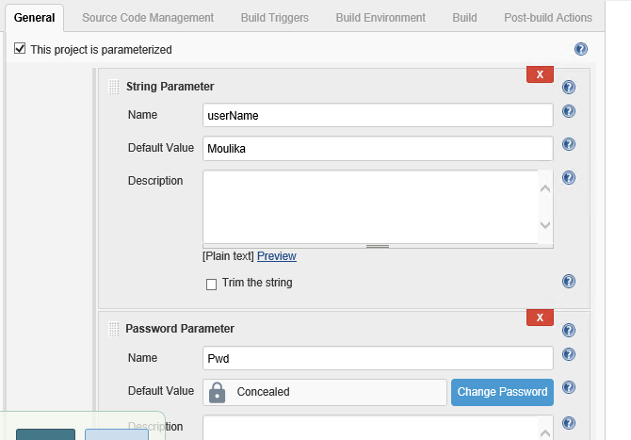

usernamePassword:

If your credentials ID is "USER_PASSWORD", you have to read it using eg. the following command: USER_CREDENTIALS = credentials('USER_PASSWORD'). After doing this, the username and password are available in the following environment variables: USER_CREDENTIALS_USR and USER_CREDENTIALS_PSW. Jenkins always adds _USR and _PSW endings to the names of the variables.

Example pipeline (I did not fully tested it, but should work):

pipeline {

agent any

environment {

USER_CREDENTIALS = credentials('USER_PASSWORD')

}

stages {

stage('Run') {

steps {

sh "echo $USER_CREDENTIALS_USR"

sh "echo $USER_CREDENTIALS_PSW"

}

}

}

}

If you get **** (four asterisks) as output, it's ok - Jenkins automatically masks usernames and passwords in the console output.

1. Click on Credentials
2. Click on “global credentials”

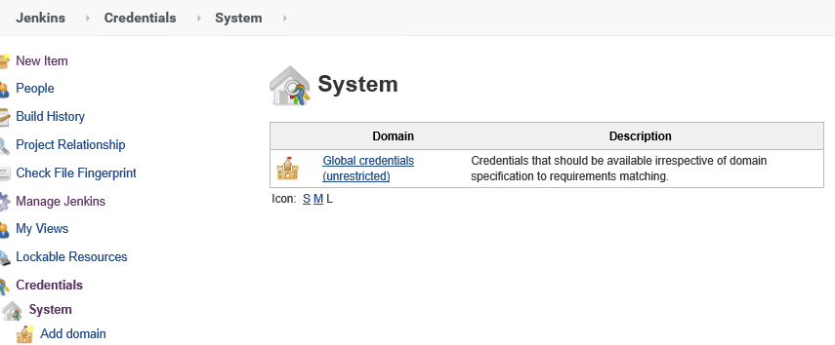

1. Select “Username with Password” and enter all fields

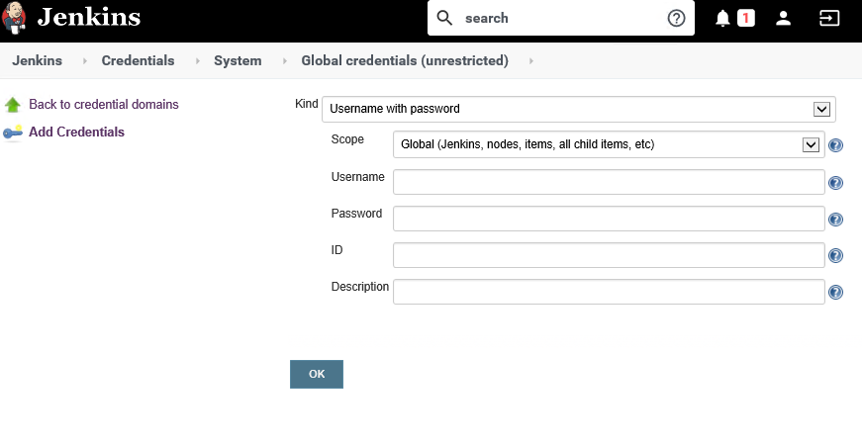

pipeline {

    agent any

    environment {

        USER_CREDENTIALS = credentials('give your ID mentioned above’)

    }

    stages {

        stage('Run') {

            steps {

                bat "echo %USER_CREDENTIALS_USR%" (if windows try like this)

                sh "echo $USER_CREDENTIALS_PSW" (if linux try like this)

            }

        }

    }

}